**EXP NO: 07**

**Aim:** To Create a simple cloud software application for Students Attendance System using any Cloud Service Provider to demonstrate SaaS include the necessary fields such as name of the students, course, present, Absent, course attendance, OD request, grade, attendance percentage, etc.

**Implementation:**

1.Go to Zoho.com and login/signup

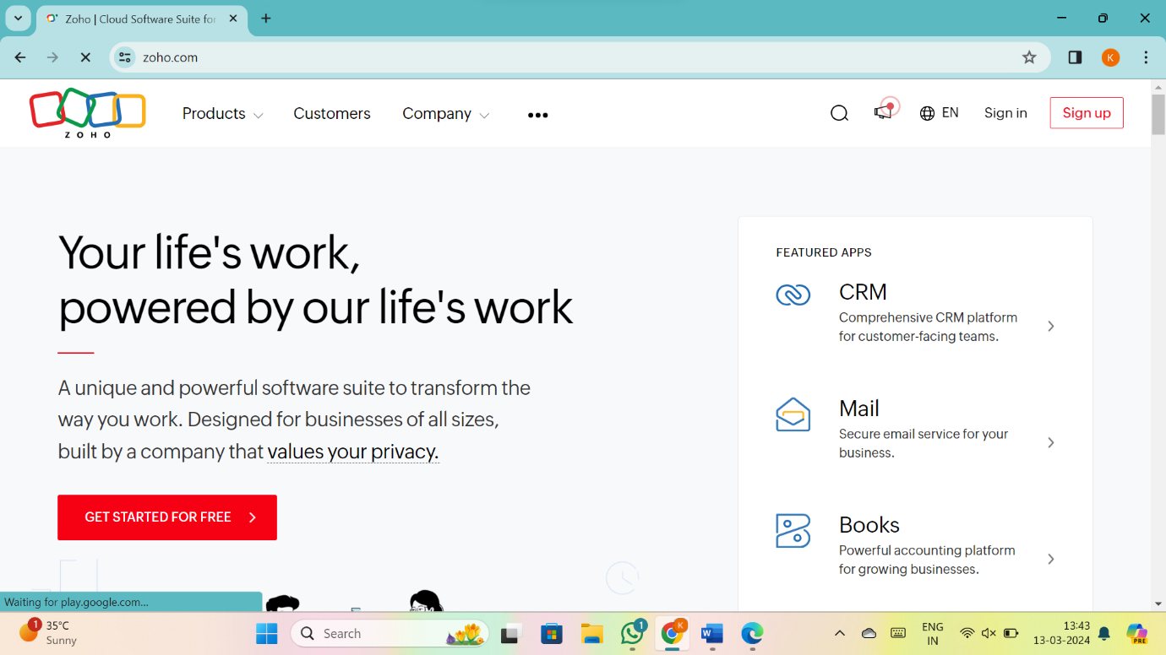

2.Go to Creator

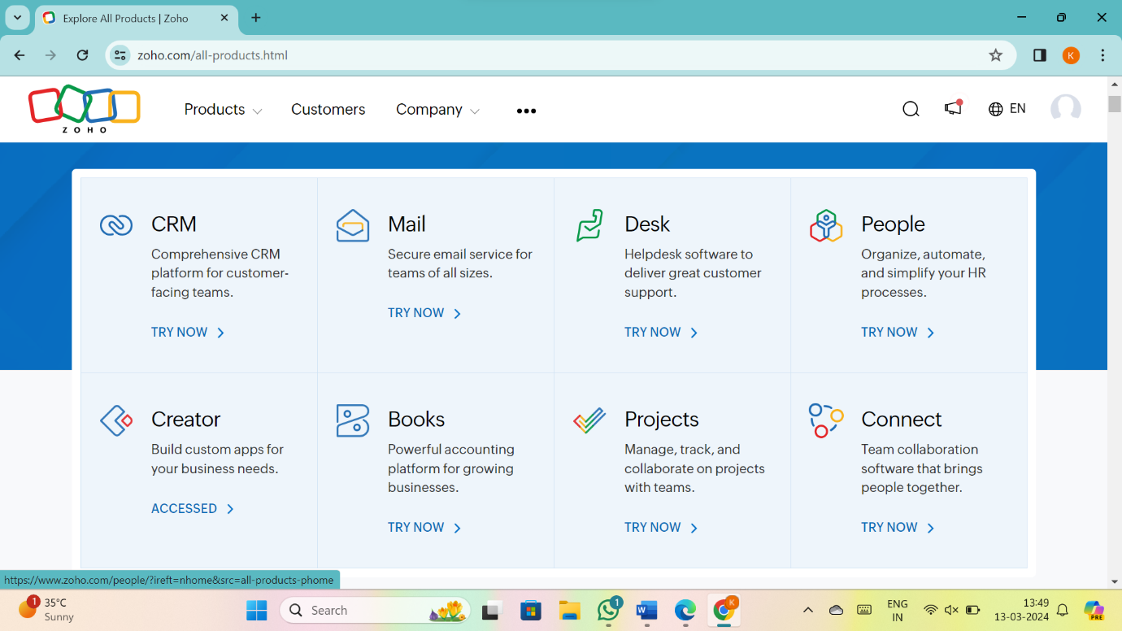

3. CREATE NEW APPLICATION

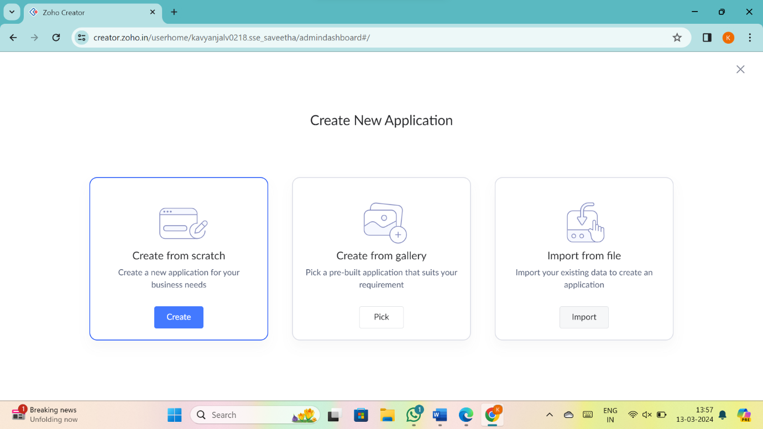

4.Give Application Name

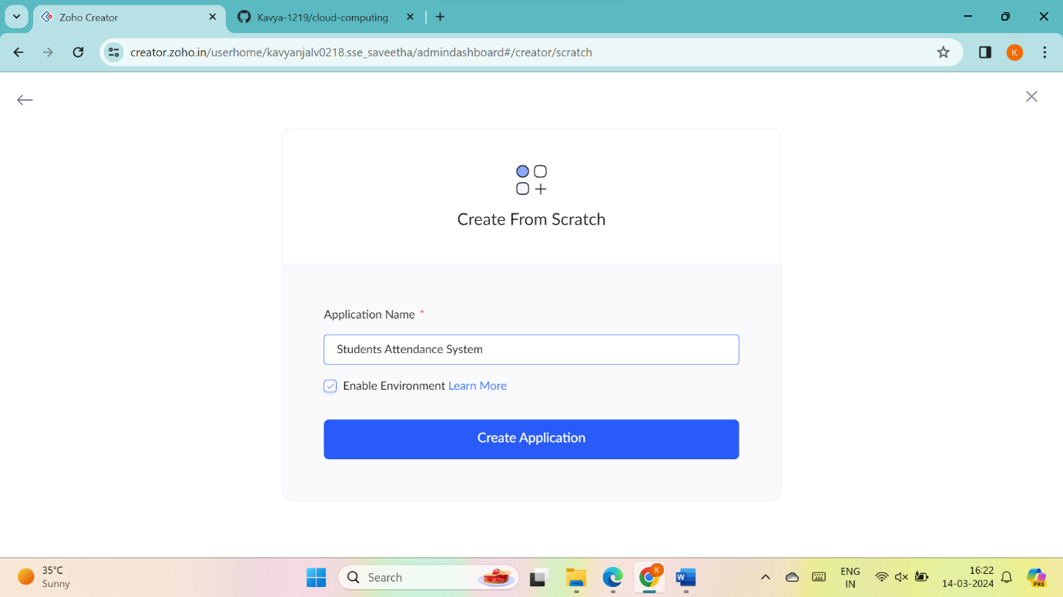

5.Create New Form

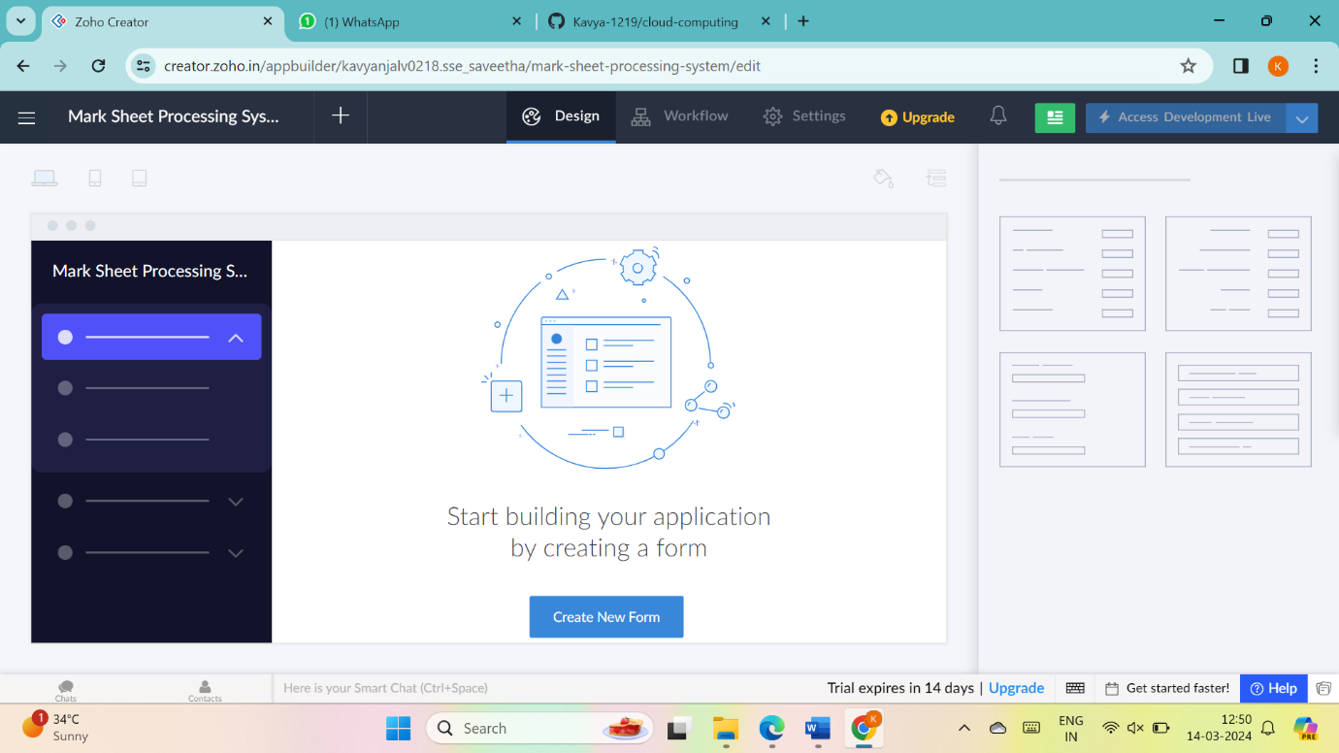

6.Select Form and give name

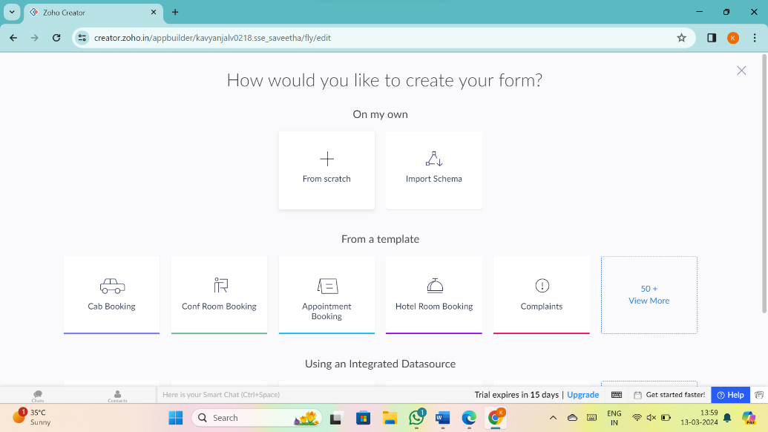

7.Drag necessary fields

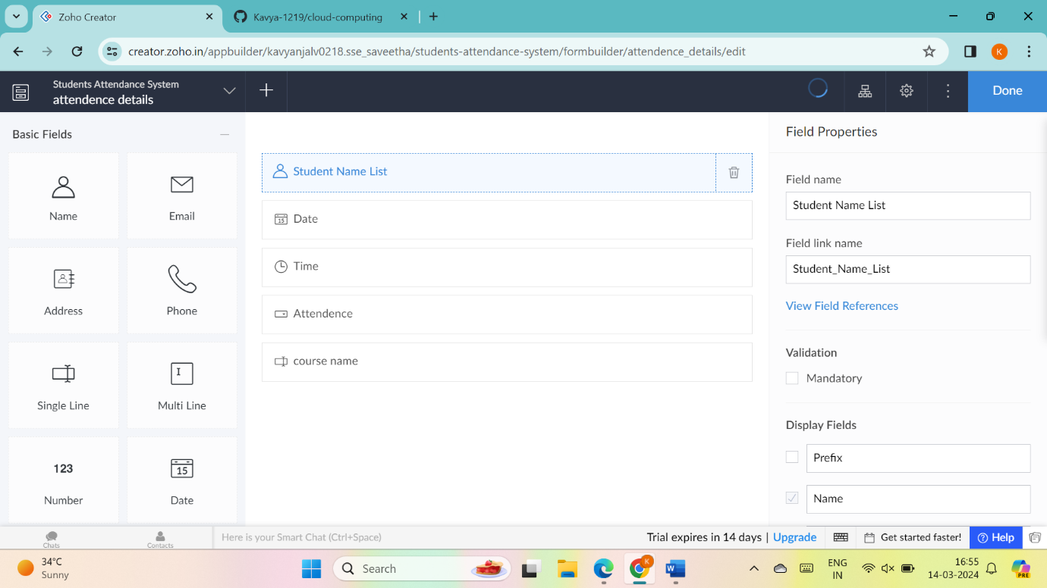

8.create new forms if necessary

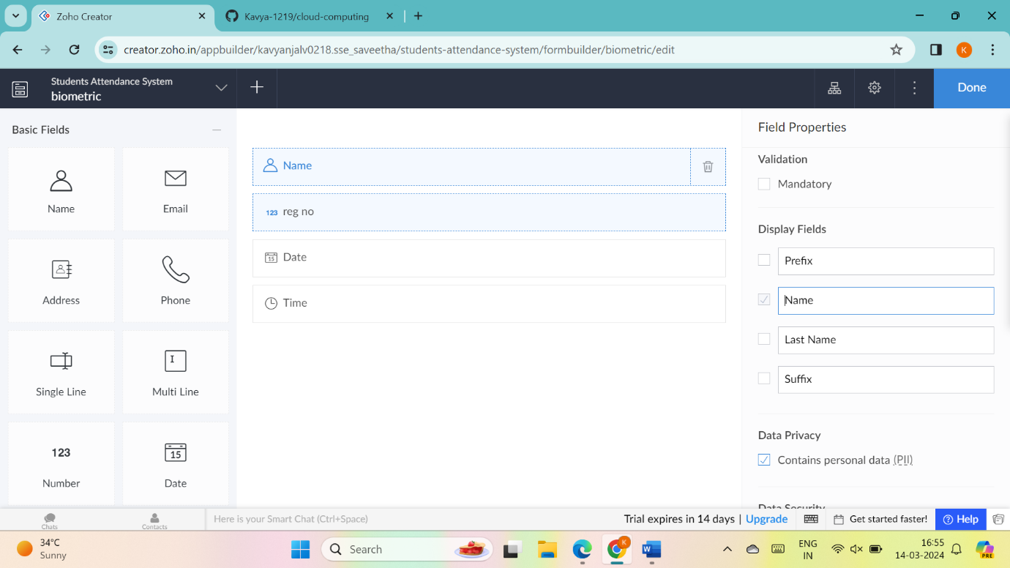

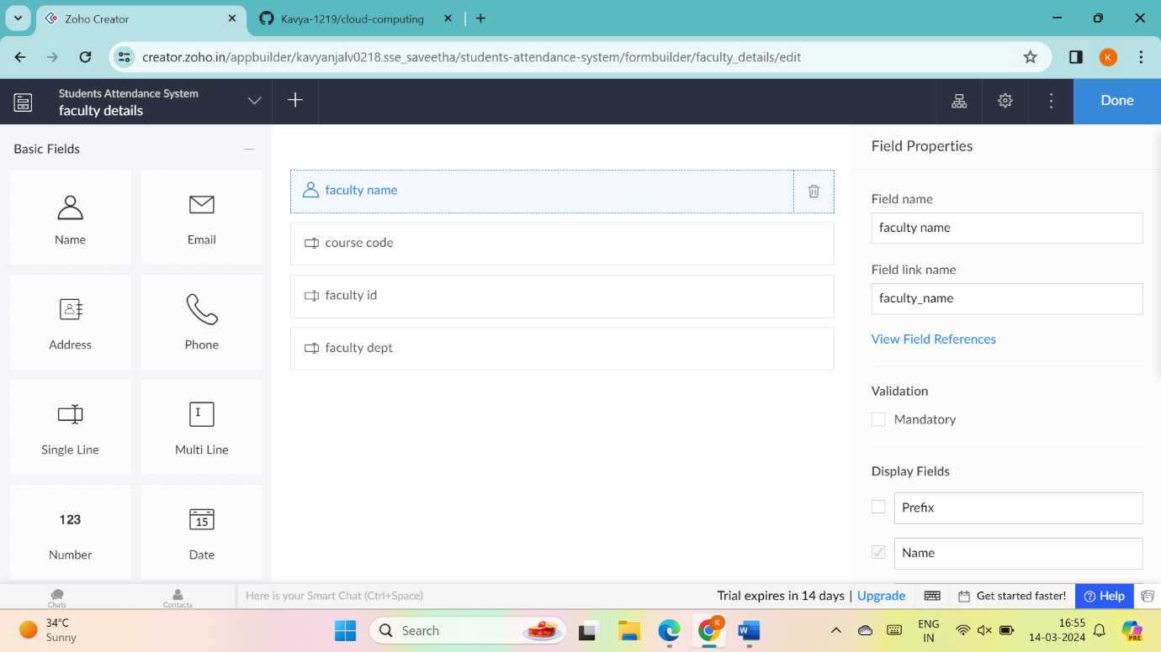

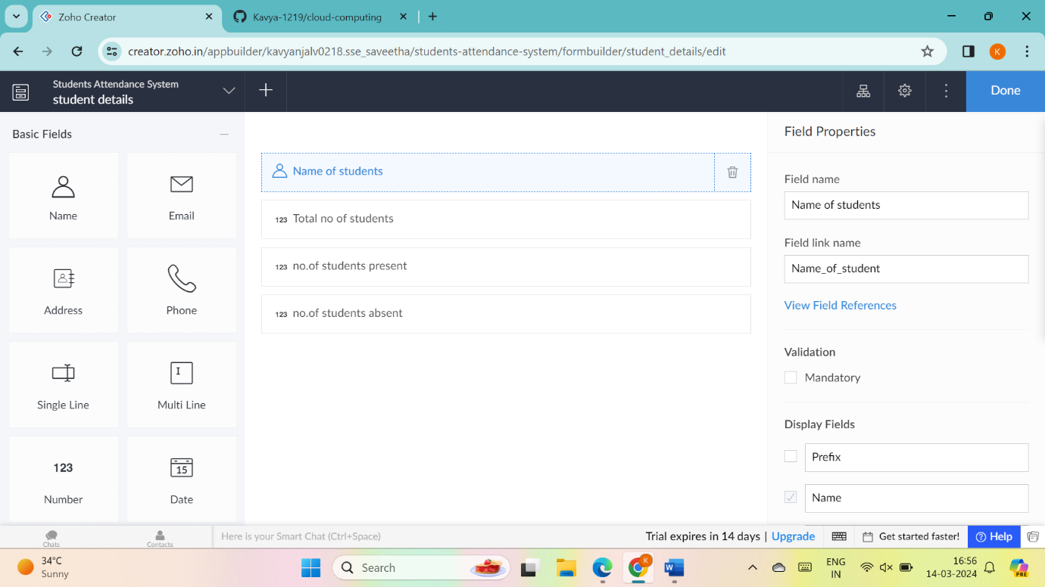

9.the software has been created

